Prof. Nicholas V.C. Polunin

Editor in Chief

Environmental Conservation

Cambridge University Press

1 Liberty Plaza, Floor 20

New York, NY 10006

USA

August 17, 2017

Dear Prof. Polunin and Dr. MacNeil,

Thank you for inviting a revision of our article ‘Using a qualitative model to explore impacts of ecosystem and anthropogenic drivers upon declining marine survival in Pacific salmon’ (EC-17-05-111) for publication in *Environmental Conservation*.

I have worked through the reviewer comments and line edits noted on the scanned copy of the manuscript and responded in the space on the journal web interface. Please note, one reviewer suggested adding the figure in Appendix 4 into the main body of the paper but due to the Journal’s limits on the number of figures and tables, I have left it in the supplementary material. If you prefer to put the figure in the main document, please let me know and I will revise to accommodate that. Also, I have made the line edits noted on the scanned copy, with one exception. I have maintained the use of a capital C in Chinook salmon, as Chinook is considered a proper noun because it is the name of native tribe.

Lastly, very recently I presented this to a group of scientists starting a new collaborative project on bottom-up processes in the region. They were very engaged and brought up a slight change: adding a linkage between microplankton and zooplankton. I have re-run the entire suite of analyses with this change. While there are a few subtle differences in the individual node perturbations, the cumulative effects analyses are quite similar to the previous version. As the model represents a collaborative effort among regional scientists and this change does not considerably impact the outcome of the analyses, I have submitted the revised version with this change incorporated.

Thank you for the opportunity to publish in *Environmental Conservation*.

Sincerely,

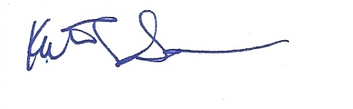

Kathryn L. Sobocinski, PhD

NOAA-Affiliate, Long Live the Kings

Fish Ecology Division

NOAA Fisheries - Northwest Fisheries Science Center

2725 Montlake Blvd. E, Seattle, WA 98112

[kathryn.sobocinski@noaa.gov](mailto:kathryn.sobocinski@noaa.gov)